DBMS Lab Assignment 10
Neeti Kurulkar
Aggregate Operations using MongoDB

Queries:
- Create Collection

- Insert Values
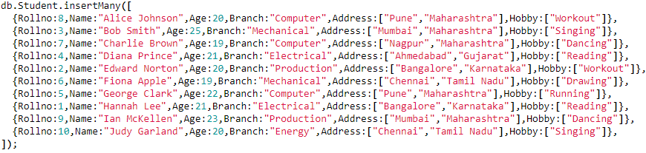
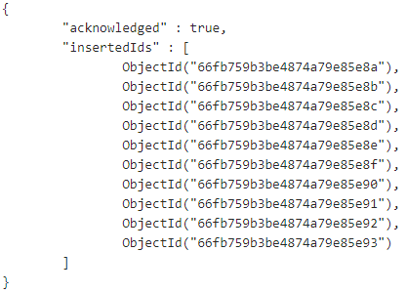
- Display values
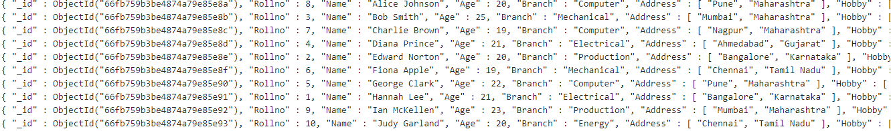

- Grouping by branch and finding min, max, first and last
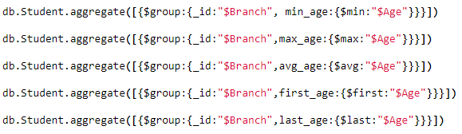
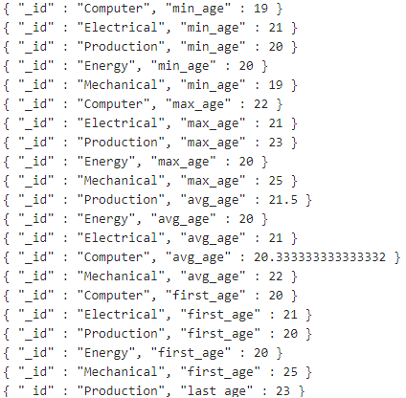
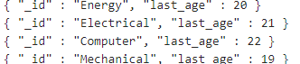

- Sorting in ascending and descending order
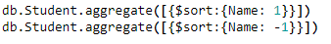
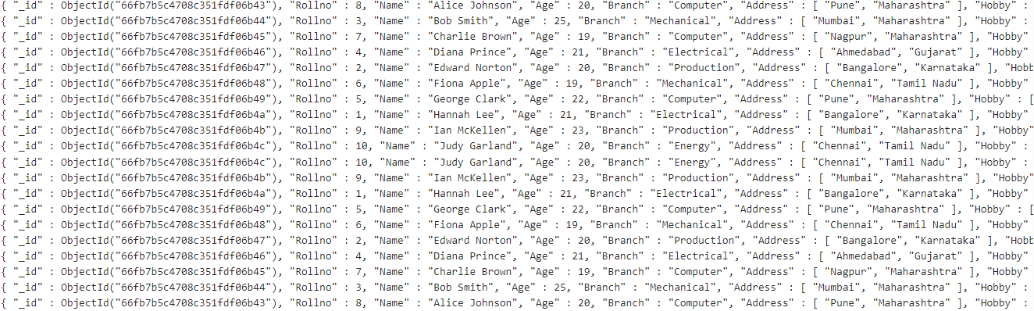

- Displaying according to branch

- Creating Index
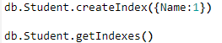
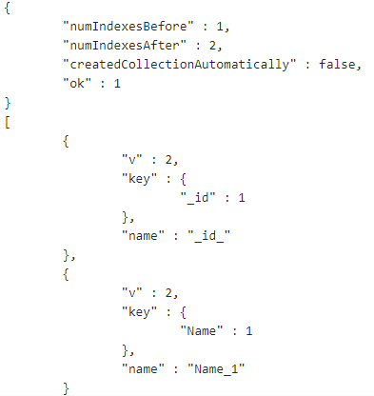
- Dropping Index

